Name: شهاب احمد عبد التواب احمد

B.N: 420

EDU MAIL: [shehab195469@feng.bu.edu.eg](mailto:shehab195469@feng.bu.edu.eg)

GETHUP link:

GETHUP page:

Application brief:

Big data is a collection of massive and complex data sets and data volume that include the huge quantities of data, data management capabilities, social media analytics and real-time data. Big data analytics is the process of examining large amounts of data. There exist large amounts of heterogeneous digital data. Big data is about data volume and large data set's measured in terms of terabytes or pet bytes. This phenomenon is called big data. After examining of big data, the data has been launched as Big Data analytics. In this paper, presenting the 5Vs characteristics of big data and the technique and technology used to handle big data.

Screen shots:

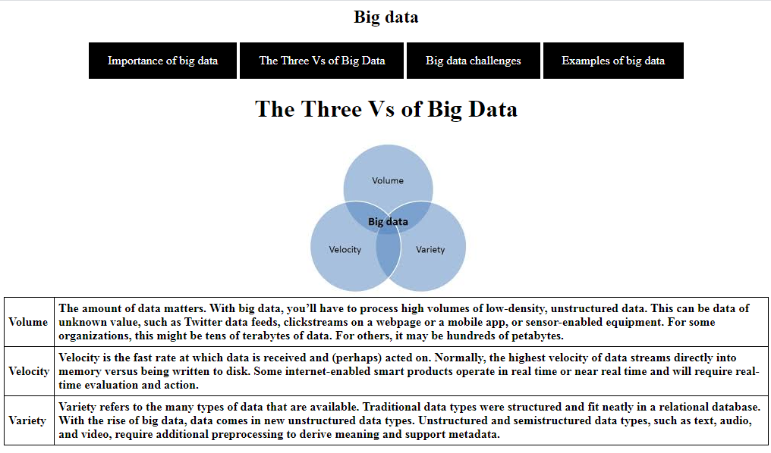

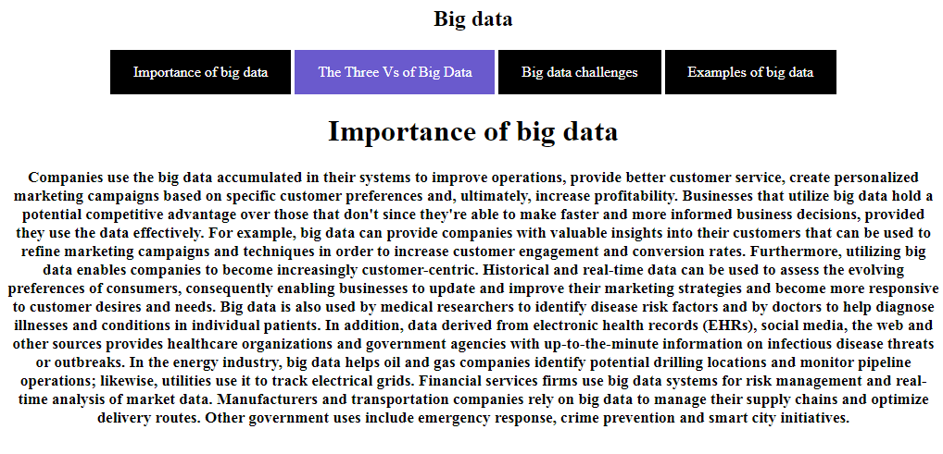

Screen source:

